LESSON PLAN
Grade: 6-8 Title of the Lesson: Nutrition in a Pandemic
Curriculum Area: Financial Literacy, Mathematics Unit of Study: __________________
Background Information: In the era of COVID-19 pandemic, we are asked to follow social distancing and to do grocery shopping less frequently. Consequently, the families stock food and other items, but have to make smart choices of what and how much to buy in view of financial and other restrictions.  Students will have had some experiences of shopping for food and/or planning meals with family members. | Guiding Questions:  What are our buying priorities or essential food items during this Covid-19 pandemic?  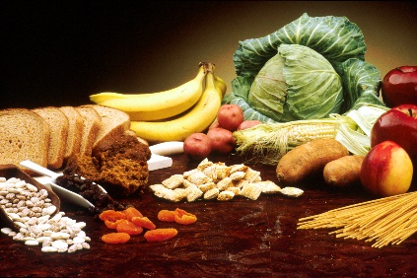

Learning Expectations:  -How to plan for food storage during a pandemic  -Distinguish between essential and non-essential foods | Curriculum Expectations  MATHEMATICAL PROCESS EXPECTATIONS: PROBLEM SOLVING: develop, select, and apply problem-solving strategies as they pose and solve problems and conduct investigations, to help deepen their mathematical understanding; REASONING AND PROVING: develop and apply reasoning skills (e.g., classification, recognition of relationships, use of counter-examples) to make and investigate conjectures and construct and defend arguments; REFLECTING: demonstrate that they are reflecting on and monitoring their thinking to help clarify their understanding as they complete an investigation or solve a problem (e.g., by comparing and adjusting strategies used, by explaining why they think their results are reasonable, by recording their thinking in a math journal); NUMBER SENSE AND NUMERATION: -solve problems that arise from real-life situations and that relate to the magnitude of whole numbers up to 1 000 000. – represent relationships using unit rates.
Lesson: Nutrition in a Pandemic  Minds On:  -Hook Question: Look around your living space. Where can food be stored so that it does not get spoiled?  -Students to go over Canada’s Nutrition Food Guide and discuss what is essential for proper daily nutrition  Action:  - Create a list of essentials using Canada’s Nutritional Food Guide for a family of four people (2 adults & 2 kids) or any other family structure  -Read: How much food from the meat and the beans group is needed daily?  Answer the following questions:  - What are proteins?  - What is fibre?  - Why are proteins and fibre important for human consumption and health maintenance?  - Which foods have proteins/fibre?  - How much protein does the average student in (your grade) need daily to maintain good health?  - Compare the amount of protein in a 100g of beef meat versus the amount of protein in 100g of black beans? Tofu? Mushrooms? Your favourite food?  - How long is it possible to store beef vs. beans/tofu/mushroom/your favourite food before it spoils?  Consolidation:  Write a paragraph to explain: Would you change anything on your initial list of essential foods you created at the start of this lesson? Why? |  | Materials/ Resources:  -Canada Nutrition Guide Website  -Article: How much food from the meat and the beans group is needed daily?  -Google Docs (to submit work/ answers)
Extension of Learning:
1. How does animal consumption (farming/hunting) affect nature?
2. How does it affect the economy when most people are working from home and are primarily consumers rather than producers?
3. Design the storage space and include specifications, measurements, and dimensions where you would store appropriate food.
4. Students design vegan/vegetarian menu for one week using weekly flyers and prices to estimate cost.
Personal Notes/Reminders/Homework/Other Considerations:

