WEEK 5 – Art Attack Math
Grade: Primary (K-3)
Unit: Geometry and Spatial Sense
Curriculum Expectation
Create models and skeletons of prisms and pyramids, using concrete materials (e.g., cardboard; straws and modelling clay), and describe their geometric properties (i.e., number and shape of faces, number of edges)

Activity
1) Students will use the prism and pyramid nets attached below to create models.
2) Students will start by cutting out the net, folding along the dotted lines and gluing the tabs in order to create the various prisms and pyramids.
3) Next students will use their models to fill in the chart below by recording the number of faces , vertices, and edges along with drawing the shapes of the faces.
Note-If you do not have access to a printer you can create models of prisms and pyramids using items from around the house (ex. clay and popsicle sticks/toothpicks/straws, cardboard, etc.). Students can also find objects from around their house that take the form of various prisms and pyramids (ex. A book is a rectangular prism).
4) Using the models of your prisms and pyramids students can decorate and assemble them using their imagination to create whatever they like (ex. House, monster, robot etc.).

Check for Understanding
I can create models of prisms and pyramids
I can describe their geometric properties
I used my imagination to create artwork out of my prism and pyramid models

Materials
Recording sheet (attached below), a pencil, prism and pyramid nets (attached below)/ items from around the house (ex. clay and popsicle sticks/straws, cardboard, etc.), glue or tape
Optional- Crayons, markers, pencil crayons, construction paper, stickers or whatever you would like to use to decorate!

Name of Prism/Pyramid | Shape(s) of the Faces | Number of Vertices | Number of Faces | Number of Edges
Cube
Square pyramid
Rectangular prism
Triangular prism
Triangular pyramid
Cylinder

Cube

Square Pyramid

Square Based Pyramid

Rectangular Prism
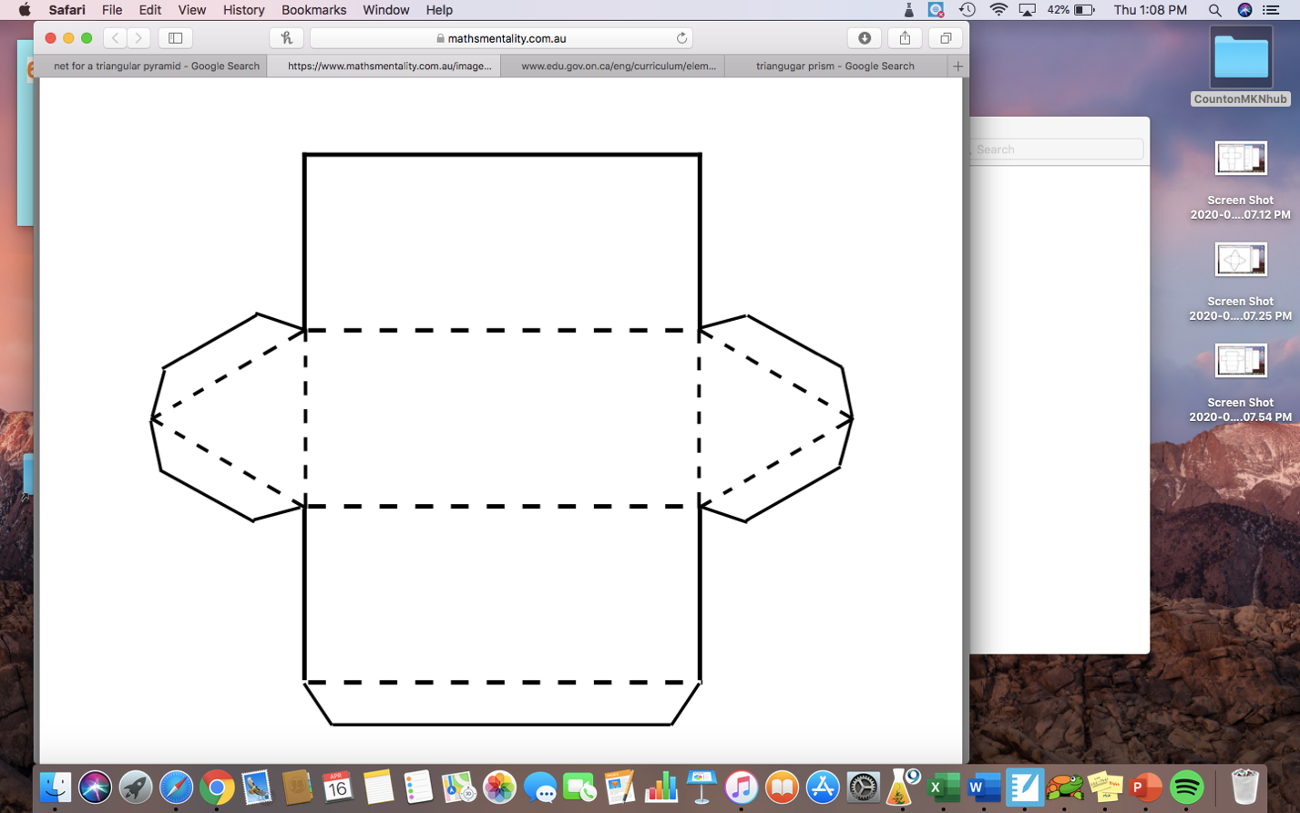

Triangular Prism

Triangular Pyramid

Cylinder

