Unit: Linear Relations
WEEK 15 – Line of Best Fit
Grade: Intermediate (9)
Curriculum Expectations
MPM 1D/MFM 1P: construct tables of values, scatter plots, and lines or curves of best fit as appropriate using a variety of tools
SEL: see themselves as capable math learners, and strengthen their sense of ownership of their learning, as part of their emerging sense of identity and belonging
Activity
1) When graphing a series of related data points using a scatter plot, there will not always be a clear linear equation, and therefore you must create a line of best fit, which is the line which comes closest to including all data points
2) You will start by seeking out a series of data points on a topic of interest to you. You can find this data online using data you find interesting, or you may use the data points below
3) You will then create a table of values (TOV) organizing the data in the order that it will appear on the x-axis
4) You then use your TOV to plot the points in a scatter plot on a graph. Your points will likely not be in a perfect line
5) Having plotted the points, you will now draw a line of best fit, which must be linear and come as close to as many points as possible.
6) Then, pick two points that your line of best fit touches and label them (x₁, y₁) for your first point and , (x₂, y₂) for your second. Then, using the equation (x₂ – x₁)/(y₂ – y₁) determine the slope of your line of best fit

Check for Understanding
I understand how to create a scatter plot with given data
I can draw a line of best fit that properly demonstrates a given data set
I understand the relevance of data in my everyday life
Materials
Recording sheet (attached below), pencil, information sheet below or internet access, calculator

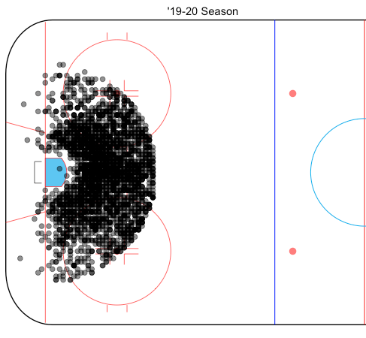
Hockey Shot Scoring Percentage Graphing

In hockey, data analysis shows that, depending on how far away and from which angle you shoot the puck on net from they can generally predict the percentage chance that you will score (this of course is impacted by the shot type, the player, the goalie etc.). For this exercise, we will be looking exclusively at the impact of wrist shot data and it’s expected goal percentage (xG%) to see if the line of best fit shows a correlation between distance and goal percentage regardless of angle.

Distance away (ft.) | xG% |  | Distance away (ft.) | xG%
60 | 10 |  | 55 | 4
62 | 5 |  | 43 | 6
53 | 7 |  | 71 | 3
8 | 30 |  | 42 | 7
12 | 24 |  | 15 | 13
13 | 22 |  | 18 | 14
14 | 26 |  | 22 | 11
18 | 15 |  | 20 | 13
22 | 12 |  | 16 | 10
23 | 14 |  | 42 | 4
26 | 15 |  | 33 | 6
55 | 6 |  | 35 | 5
29 | 13 |  | 24 | 15
33 | 18 |  | 4 | 36
61 | 5 |  | 6 | 34
64 | 8 |  | 2 | 33
64 | 4 |  | 15 | 12

