WEEK 2 – Dream Trip Planning
Unit: Algebra
Grade: Intermediate (7-8)
Curriculum Expectations
identify and compare a variety of repeating, growing, and shrinking patterns, including patterns found in real-life contexts, and compare linear growing patterns on the basis of their constant rates and initial values
SEL: make connections between math and everyday contexts to help them make informed judgements and decisions

Activity
1) You will plan a post-quarantine vacation to a destination of your choice, this can be either one of the destinations listed below or a destination of your choice.
2) Students will pick a city as a destination and day trip to take from that city
3) Students will research the distance required to get from the closest airport to their home to their chosen city. They will then research the distance from their chosen city to their chosen day trip.
4) Students will choose the most efficient mode of travel to get both to their city and to their day trip destination and research how fast they will travel with their chosen method (km/h)
5) Students will then fill out the attached table of value with the relationship of travel from their home airport to their chosen city and the distance from their destination city to their day trip location.
6) Once the table of values are filled out, students are to plot the points on separate chart paper or a printed cartesian plane

Check for Understanding
I can connect my knowledge of speed and distance to a real world travel scenario
I understand the relationship between time and speed at a constant rate
I can plot points on a cartesian plane after filling out a table of values
Materials
Recording sheet (attached below), pencil/pen, chart paper/grid paper/cartesian plane marked on blank paper, ruler/straight edge,

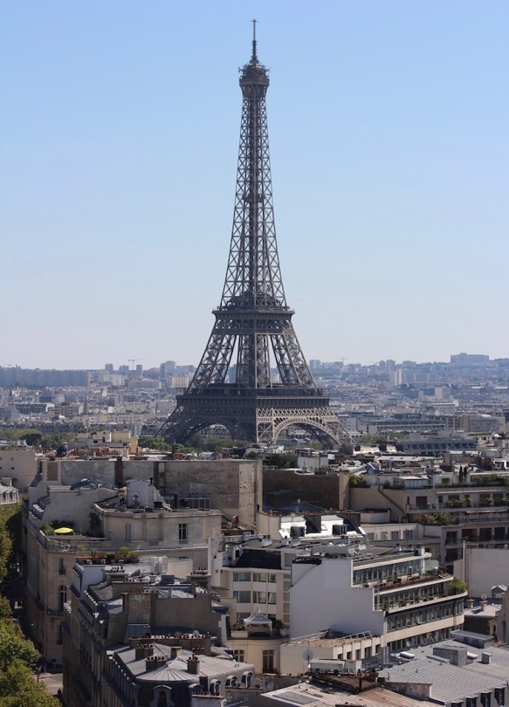
Travel Destination and Day Trips Options (or choose your own)
Paris, France
-Palace of Versailles
-Disneyland Paris
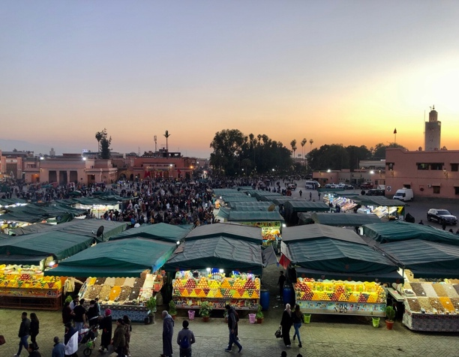
Marrakech, Morocco
-Atlas Mountains
-Essaouira

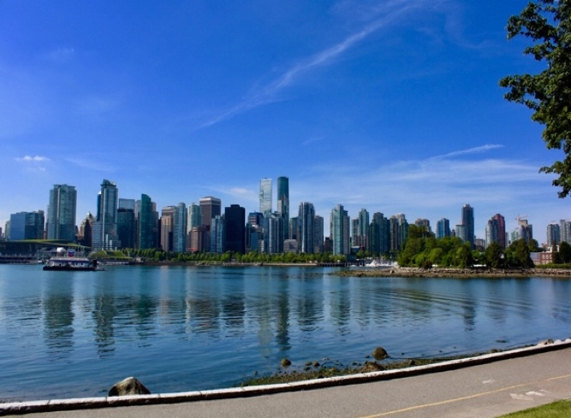
Vancouver, BC
-Whistler ski resort
-Victoria

Kyoto, Japan
-Osaka Castle
-Nagoya

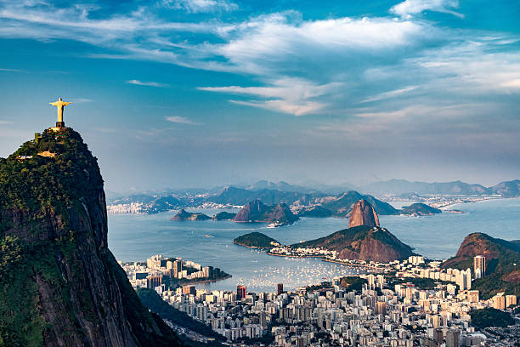
Rio de Janeiro, Brazil
-Tijuca Forest National Park
-Petropolis

Auckland, New Zealand
-Hobbiton
-Waitomo Caves

Where are you travelling to and how far is it from home? _______________________________________________
Where do you want to go for a day trip and how far is it from your destination? _______________________________________________
In the tables below choose the most effective method of transportation and plot the time it takes to get to your destination/day trip and the distance that you travel. Then plot these points as a line graph on a separate piece of graph paper.
Travel Time: Table of Value to your Destination
Method of travel (plane, car, train etc.) and speed of this method (km/h)
________________________
Time (Hours or ½ hours)  x-axis | Distance Travelled (kms)  y-axis
Travel Time: Table of Value For your Day Trip
Method of travel (plane, car, train etc.) and speed of this method (km/h)
________________________
Time (Hours or ½ hours)  x-axis | Distance Travelled (kms)  y-axis

