WEEK 6 – Dilate a Comic Strip
Unit: Spatial Sense

Grade: Intermediate (7-8)
Curriculum Expectation
perform dilations and describe the similarity between the image and the original shape
SEL: recognize that testing out different approaches to problems and learning from mistakes is an important part of the learning process, and is aided by a sense of optimism and hope

Activity
1) Your task will be to utilize your knowledge of transformations, specifically dilations to dilate a panel from a comic strip
2) Using a comic of your choosing and putting it onto a grid to measure elements of the comic, or the comic below, which measures 8cm by 8cm fill in the measurement scaling chart with the measurements of important elements from the comic panel (major pieces of the picture that you can then base the smaller pieces around
3) Using the measurements of you comic panel, you will write the approximate measurements that your comic would be if dilated to on a 16 cm by 16 cm grid
4) Once you have completed the approximate measurements try sketching the comic onto the attached 16 cm by 16 cm grid
5) Once you have sketched the dilated comic, insert the measurements of your actual drawing and see how close you were
Note: If students do not have a printer for the comic, find a picture in your house that you can draw on (you can also draw it yourself) and draw an 8 cm by 8 cm grid over top of it. Then try dilating that image to a 16 cm by 16 cm grid writing the measurements as you go.
Extra Credit: If you want an extra challenge try dilating down to a 2 cm by 2 cm grid

Check for Understanding
I can measure elements of an image given a measurement grid
I can estimate dilated elements of an image given two sets of measurement
I draw an approximately scaled dilated picture given two sets of measurements.

Materials
Recording chart (attached below), pencil, comic strip, pencil crayons

Comic to Scale 8cm by 8cm
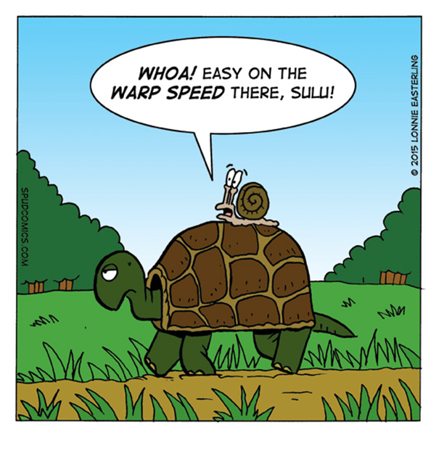

Measurement Scaling
Visual Element | Original Measurement | Predicted Measurement | Dilated Drawing Measurement
Turtle shell | 3.1 cm by 2.5 cm | 6.2 cm by 5 cm

Dilated Comic Drawing 16cm by 16cm

