WEEK 10 – Tessellation Art
Unit: Spatial Sense

Grade: Junior (4-6)
Curriculum Expectations
Describe and perform translations and reflections on a grid, and predict the results of these transformations
SEL- See themselves as capable math learners, and strengthen their sense of ownership of their learning, as part of their emerging sense of identity and belonging

Activity
1) Your task is make tessellation art, that is you will use one or more geometric shapes to tile an entire piece of paper
2) There are to be no gaps and no overlaps in your drawings of you tessellation art and you must fill the whole page
3) Start with a design made up of geometric shapes that you combine in a set order. (See an example below. Colour each of the shapes a different colour to distinguish them
4) Now, use your knowledge of transformations (reflections, translations etc.) to move your tessellation pattern around the piece of paper until you have tiled the entire plane
5) If the tessellation patter extends beyond the end of the paper, cut off the tessellation patterns at the end of the paper.
Extra Credit: If you finish with one tessellation piece and want to make it more challenging, try to combine more geometric shapes to create a new pattern

Check for Understanding
I can combine shapes to create a tessellation
I understand the transformations required to fill a plane completely without any gaps
I can create increasingly difficult tessellations to tile a plane

Materials
Recording sheet (Attached below), pencil, piece of paper, pencil crayon (or marker/other colouring utensil

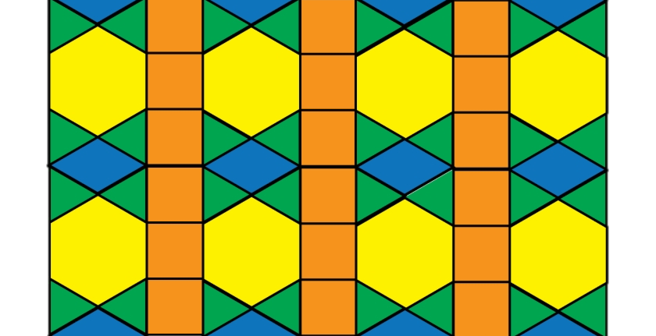

Follow up Questions:
Where did you start your pattern on the sheet of paper and why?

How many tessellations did it take to tile the whole paper?

What was the most common transformation you used and why?

