**WEEK 9 – Race Against the Clock**

**Unit:** Spatial Sense

**Grade:** Primary (K-3)

**Curriculum Expectation**  
Use analog and digital clocks and timers to tell time in hours, minutes, and seconds  
**SEL**-Express and manage their feelings, and show understanding of the feelings of others, as they engage positively in mathematics activities

**Activity**1) In order to pass time during the quarantine students will play a game all about time! Either with themselves or against a partner (ex. Parent, sibling, etc.) students will learn to create different times on an analogue clock.   
2) Students will print the spinner and the analogue clock below.  
3) Students will use two different sized sticks (ex. Popsicle sticks, pencils, playdough, etc.) to represent the hands of the clock in order to create the time noon.  
4) Then using a pencil and a paper clip to create a spinner students will flick the paper clip to randomly pick an amount of minutes. For students who do not have these materials they can also write down the different number of minutes on small slips of paper and put them into a bag in order to pick one randomly.  
5) Students will either add or subtract the amount of minutes accordingly, record their new time in the chart and adjust the hands of the clock to the new time.  
6) The goal of the game is to make it to 6 o’clock in the fewest number of spins!  
  
**Joke of the day:** Why was the clock sent to the principal’s office?  
Because he was TOCKING too much in class!

**Check for Understanding**   
I can tell and write time using an analogue clock.  
I can identify the different hands on a clock.

**Materials**   
Analogue clock, spinner and chart (all attached below), 2 different sized sticks (ex. Popsicle sticks, pencils, playdough, etc.) pencil and a paper clip/ slips of paper and a bag

|  |  |
| --- | --- |
| **Minutes Added/Subtracted** | **New Time** |
|  |  |
|  |  |
|  |  |
|  |  |
|  |  |
|  |  |
|  |  |
|  |  |
|  |  |
|  |  |
|  |  |
|  |  |
|  |  |
|  |  |

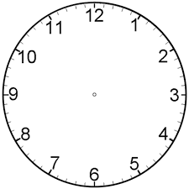

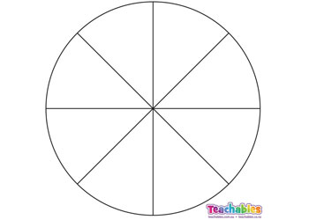

Add 60  
minutes

Subtract 15  
minutes

Add 30  
minutes

Add 60 minutes

Subtract 30  
minutes

Add 30  
minutes

Add 15  
minutes

Subtract 15  
minutes